Class diagram:

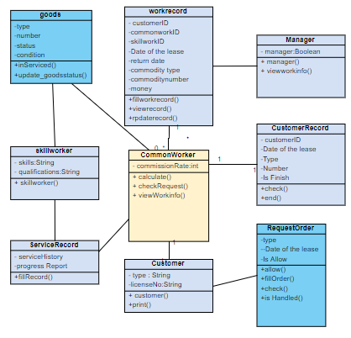

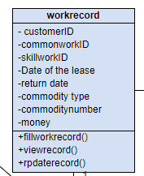

Staff work record class：

Attribute：The customer account（customer ID）, Staff account(commonworkID), Technical account(skillworkID), Date of the lease,return date, Type of item rented(commodity type),number,money

Methods: Fill out this record, View this record, Modify this record

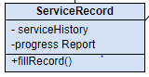

Rental service record class(Records of each rental service)

Attribute: Service history,progress report

Methods: Used to fill in the form(fillrecord())